GLOBAL GAMING EXPO
Sands Expo & Convention Center

PRE-SHOW PRODUCT OVERVIEW
September 2017

Konami Gaming, Inc. is showcasing a variety of popular core gaming options, exciting multi-station developments, leading skill-based entertainment, and casino systems advancements during the 2017 Global Gaming Expo (G2E) in Las Vegas on October 3 – 5. An estimated 27,000 casino professionals from around the world will have access to a captivating suite of games and systems technology on display at Konami booth #1154. Designed to attract and engage player audiences with a uniquely exciting play experience over time, G2E debut releases including new game themes, progressive bonuses, next generation products, analytics tools, and advanced player tracking functionality will be featured for guests to see and enjoy.

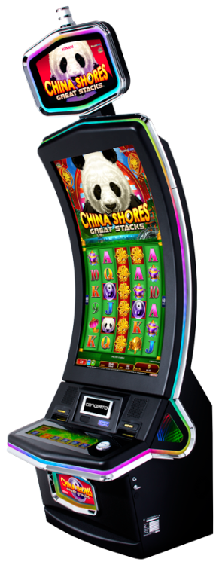

Konami’s curved Concerto Crescent™ and tall Concerto Stack™ both feature a stunning 43” HD vertical display, with signature Concerto highlights such as the unique side lighting element and sleek black finish. These single-screen formats give players exclusive game content designed to optimize the machines’ extra-tall portrait orientation. Games that don’t include a built-in progressive jackpot have the option to add a 2-level standalone or linked progressive with fully configurable “must-hit-by” range amounts for those jurisdictions that allow. Concerto Crescent and Stack both maintain a standard upright base size for flexible configuration across the casino floor.

China Shores Great Stacks™
China Shores Great Stacks is a tall 6x5 reel version of the iconic original that doubles the number of reel positions for potential free games and Action Stacked Symbols®. Fans have the chance at big free game awards with 2x all wins. China Shores Great Stacks also has a variety of options for players to choose during the Balance of Fortune™, including a random credit prize, bonus multipliers, and bonus picture symbols.

Mayan Chief Great Stacks™
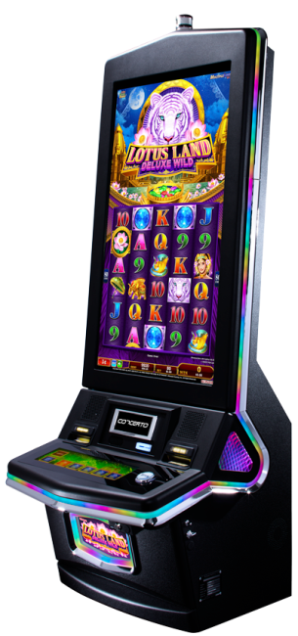
Konami’s popular Mayan Chief™ is also arriving to Concerto Stack and Crescent with a new 6x5 reel format. This 60-line game features Action Stacked Symbols and top free game awards for big-impact excitement. During the Balance of Fortune feature, players can select from a mix of super free game options, regular free games with 2x all wins, or a random credit prize.

Lotus Land Deluxe Wild™
The recognizable white tiger from Konami’s top-performing Lotus Land™ is making its return with a new tall 6x5 reel format designed to showcase surprising multiplier game play on Crescent and Stack. During the free games, wild symbols appearing on reels 2, 3, and 4 transform into random multipliers, and can even trigger a bonus re-spin feature for additional wins.

Dragon Emblem Jackpots™
Dragon Emblem Jackpots is a 7-8-8-8-7 game that features a symbol-driven jackpot progressive. Throughout game play, wild dragon emblem symbols randomly activate with a red or blue glow, alerting players to a progressive chance. By collecting matching red or blue dragon emblems on 3 different reels, players are awarded the maxi or major jackpot respectively. A mix of red and blue dragon emblems on 3 reels results in the mini award. Dragon Emblem Jackpots is an Xtra Reward® game and includes a free game feature.

Lucky O-Leary Jackpots™
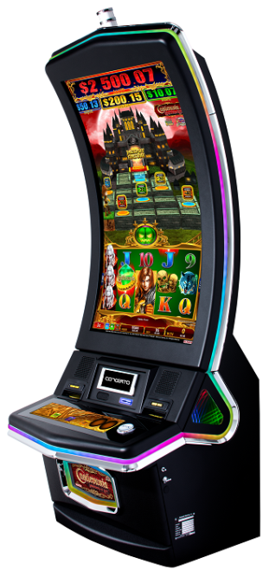
Players are on the hunt for the leprechaun’s shining pot of gold in Konami’s new Lucky O-Leary Jackpots. This 7-8-8-8-7 game includes a 3-level progressive jackpot chance, with increasing odds at higher bet levels. Players can win a maxi, major, or mini jackpot by collecting specially-activated wild pot of gold symbols of blue and red. During the free games, Lucky O-Leary awards over 240 additional wilds, according to the number of four leaf clover trigger symbols collected.

Konami is showcasing the next chapter in Castlevania™ themed video slots at G2E 2017 with two new themes for guests to explore. Based on the iconic video game first popularized in the 80’s, Castlevania: Labyrinth of Love™ and Castlevania: Ring of the Heavens™ explore new territories, beasts, and monsters across the 43”canvas of Konami’s Concerto™ Crescent™ curved screen cabinet. Authentic art, animation, and music from the series are found throughout, with multi-mystery bonus adventures that bring the legend of Castlevania to life.

Castlevania: Labyrinth of Love™
A slightly darker take on the original debut title, Castlevania: Labyrinth of Love takes place in the unique setting of a moonlit, mountaintop castle across a stormy red sky. Players have the chance to take on monsters, slay the undead, and become a legendary hero with fun free games, arcade-inspired bonus features, and progressive bonus battles. Expect to hear classic 8-bit music from the original video game and encounter favorite key characters at fun and surprising moments.

Castlevania: Ring of the Heavens™
Castlevania: Ring of the Heavens features a never-before-seen, symbol-driven progressive bonus throughout primary play. Whenever a feature wild symbol appears on reels one and five, players enter the Castlevania Feature and follow the hero through a trial against the dark forces. Castlevania: Ring of the Heavens includes a built-in incentive for higher jackpot odds at extra bet levels.

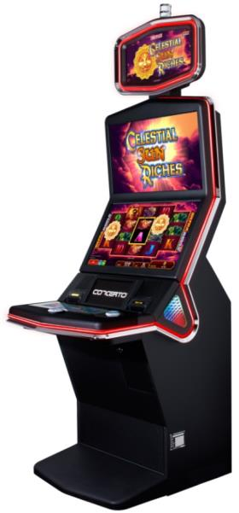
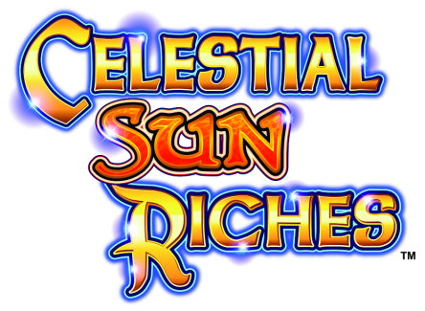

Konami’s newest available progressive series uniquely combines multipliers, random credit awards, free games, and a big hit jackpot prize to give players a variety of win opportunities at higher odds as they increase their bet amount. Celestial Sun Riches™ and Celestial Moon Riches™ are all-new ULTRA REELS® series games that feature a selectable Strike Zone™ area to activate additional bonus opportunities. Players can increase their extra bet amount to further expand the Strike Zone, where every wild eclipse symbols transforms to random 2x or 3x multipliers and each sun or moon symbol awards a wheel bonus if the free game feature is triggered.

During the wheel bonus, players have the chance to win credit prize awards, additional free games, 3x or 5x wild multipliers, and the big jackpot. The free game feature begins directly after the wheel bonus and all wins are doubled during the free games. Celestial Sun Riches and Celestial Moon Riches are available exclusively on Konami’s Concerto™ cabinet lineup, including Concerto upright and Concerto Slant™.

Konami’s popular SeleXion® is now bringing the industry’s most agile and customizable multi-game technology to a record variety of Concerto cabinets. In addition to showcasing SeleXion on Concerto upright, during G2E 2017 Konami will debut its first single-screen multi-game cabinet on its tall Concerto Stack. SeleXion’s new single-screen functionality also extends to Concerto Crescent. SeleXion’s robust processing power gives players the fastest game change speed and an optimal interface to enjoy a fun mix of their favorite games in one spot. Operators can custom select up to 10 different game themes on a single machine, as well as a progressive bonus.
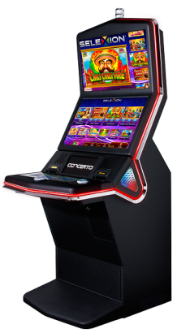
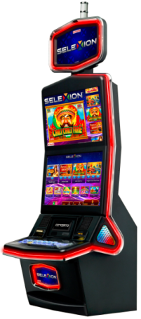
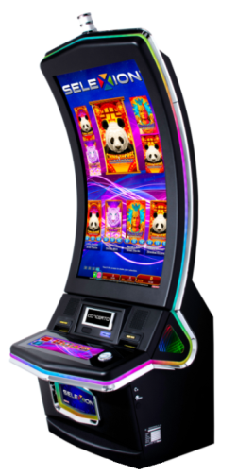
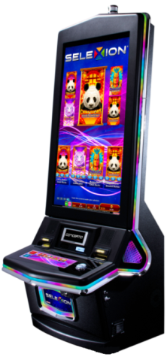

SeleXion’s expansion to Concerto Stack and Concerto Crescent provides a versatile solution for casinos to feature a rapidly expanding library of single screen game releases from Konami. New single screen titles like China Shores Great Stacks™, Mayan Chief Great Stacks™, Lotus Land Deluxe Wilds™, Dragon Fury™, and Pharaoh’s Fury™ can all be featured on one machine. Players have access to an entertaining variety of the latest games with one of the most popular multi-game platforms globally.

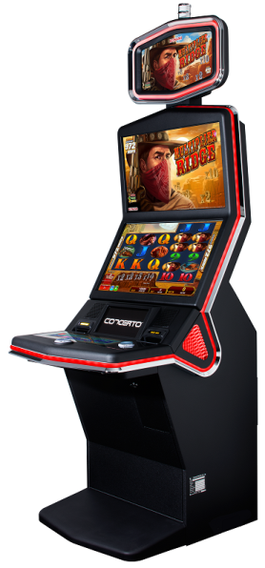

Konami’s top-performing Concerto Slant™ carries dual 27” HD game screens with a low profile and relaxed-angle posture for player comfort and convenience. Concerto Slant supports any KP3+ platform content found on Concerto upright and is also backward compatible with proven KP3® platform titles such as Dragon’s Law™, Lotus Land™, China Shores™, and many more. With digital topper removed, the Concerto Slant offers enhanced sightlines across any busy slot floor.

Scroll of Wonder™
Mystery multipliers are the magic behind Konami’s new ULTRA REELS title: Scroll of Wonder™. During the free game feature, all wild scroll symbols are transcribed in a shimmer of light to reveal 3x, 4x, or 5x random multipliers—an effect made even more exiting by the game’s exceptionally high volume of Action Stacked Symbols.

Multiplier Ridge™
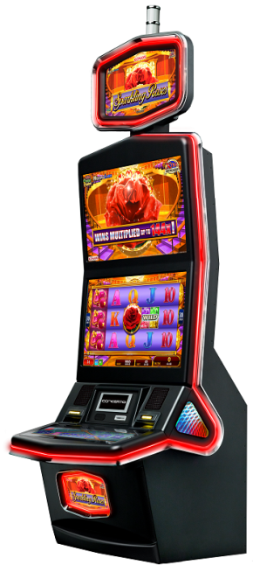
Another new release with a focus on multipliers is Multiplier Ridge. Part of Konami’s ULTRA REELS 972 WAYS™ series, Multiplier Ridge awards wins for left to right adjacent symbol combinations—972 possible combinations in total. Throughout game play, any 5-of-a-kind wins ignite a burst of dynamite explosions on the mountain ridgeline, revealing a random multiplier award of 2x, 3x, 5x, or 10x, for that extra spark of excitement.

Characterized by its sleek immersive design and backed by the powerful KP3+™ platform, Konami’s Concerto video slot cabinet has become one of the industry’s top-performing standard upright cabinets. Since its debut, Concerto’s proven qualities have expanded to a complete lineup of video slot offerings with a rich library of original game content. During this year’s G2E show, guests will see a vast selection of base games and never-before-seen standalone and linked progressives.

Sparkling Roses™
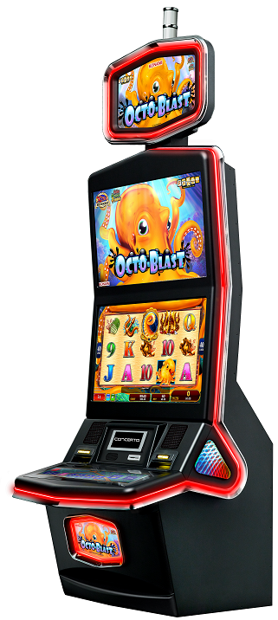
Konami’s Multiple Lines 15 REELS™ series is showing continued success with the addition of Sparkling Roses. Sparkling Roses features 15 independent reels in a 3x5 grid and an Xtra Reward feature that randomly awards bonus multipliers throughout primary play. This combined with Action Stacked Symbols across all 15 reels provides ample opportunity for big-win excitement.

Great Moai™
With inspiration from the monuments first created by the Rapa Nui people of Easter Island thousands of years ago, Great Moai brings these remarkable carvings to life with surprising effect. In this original math game, Moai statues appearing in the top screen shoot down to the lower reels to become either full-reel wilds or full-reel wilds with 2x multipliers. In addition, upon arriving to the reels the full-reel Moai symbols randomly hop toward reel 1, increasing anticipation of even greater line win combinations.

Octo-Blast™
Using the popular Fade Away® symbol replacement feature first premiered on Chili Chili Fire™, Octo-Blast is randomly inking out the lower value card symbols and leaving top-value symbols in their place. The game’s bright orange colored octopus holds the reel frame in his tentacles, and when the Fade Away Feature is triggered he glows bright blue and inks away all the card symbols for huge potential line wins.

Egyptian Wheel™ (SAP)
Able to combine with most any KP3 platform base game, Egyptian Wheel is a mystery trigger jackpot bonus game with a never-before-seen wheel spin mechanic. When the Egyptian Wheel feature is triggered, players select one of four slices from the wheel, all with equal odds. If the sphinx eye lands on the players’ selected slice of the wheel, they are awarded the corresponding prize and select another slice. If they succeed in selecting 4 of 4 slices, the player is given a spin on the jackpot wheel with a guaranteed prize.

Luxury Jackpots™ (LAP)
Luxury Jackpots is a 4-level linked progressive that is compatible with most any KP3 platform base game and features an attractive $10,000+ maxi jackpot. This mystery trigger progressive showcases a pick ‘em bonus that allows players to match 3 symbols to determine their progressive level award. Each jackpot level is represented by luxury items of increasing value including a sports car, speed boat, and private jet.

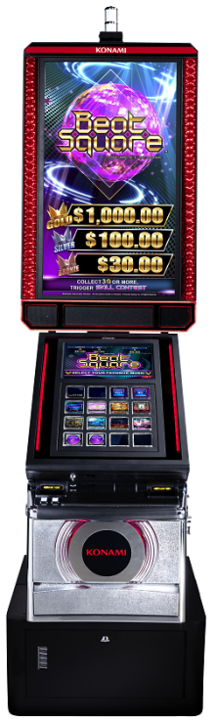
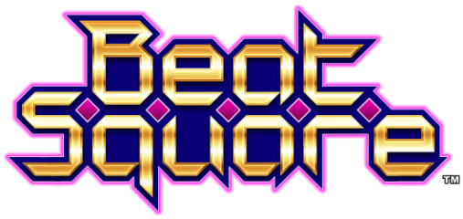

Leveraging the company’s expertise in popular consumer arcade and video games, Beat Square™ challenges gamers to play, compete, and prove their skill in a game of rhythmic coordination across a lighted touch pad dashboard, packed with new and recognizable tunes. Based on technology developed through iconic Konami creations like Dance Dance Revolution, Beat Square is the casino industry’s first musical rhythmic dexterity skill-game. It combines video game and arcade entertainment with original for-wager mathematics in order to provide casino players with a skill-based gaming experience that appropriately awards top players and new players alike.

When the player selects a song and the game begins, different squares illuminate in rhythmic patterns, which the player taps in tempo to achieve higher points and random credit awards. Players can try their skill against the high scores leaderboard during single player mode, or compete with up to eight people during a Beat Square Tournament. Beat Square provides an exciting skill-based experience unlike anything else ever shown to market, with fun rhythmic game play, shared social interaction, big-win competitive leaderboards, and original for-wager mathematics to appropriately reward players within an engineered payback percentage.

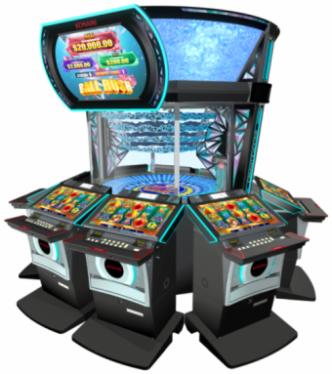
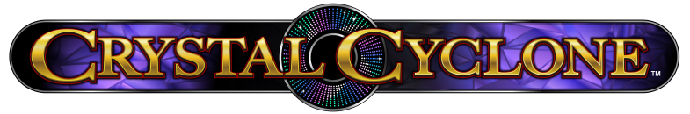

In the spirit of Konami’s proven Titan 360™ multi-station machine, Crystal Cyclone™ is a colorful, high-energy mechanical bonus game that can simultaneously connect all players to a center roulette-style progressive feature for big wins and excitement. Each player has an individual video slot station with proven base game themes, further enhanced by this one-of-a-kind community-style jackpot experience.

Crystal Cyclone is comprised of eight slant top games that trigger one of three different mystery bonus events in the center ring. During the game’s most anticipated event, the player is awarded 60 prize balls, which flood the center ring 10 at a time, each awarding a random credit amount for the prize slots they land.

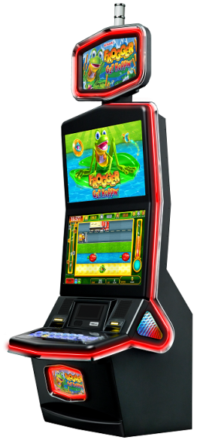

Earlier this year, Konami’s Frogger: Get Hoppin’™ made history as the first primary skill-based casino game in the state of Nevada for players to enjoy. Similar to the unforgettable arcade game, Frogger: Get Hoppin’ invites players to move the frog left and right across the screen to the tune of a recognizable melody, seeking safe landing and avoiding cars, alligators, and open water. The player’s score increases as they move further and further through the course, with extra bonus points for collecting coins and bugs. Players can improve their payback percentage and even earn pure skill-based cash awards, based on how quickly and accurately they navigate Frogger through the game.

When time runs out, players have the chance to win a credit prize or progressive jackpot. In addition, Frogger: Get Hoppin’ features three true skill-based jackpot prizes: bronze, silver, and gold. Each can be earned by for reaching certain score thresholds. Frogger: Get Hoppin’ also allows players to earn their initials on the machine’s weekly and all-time high scores leaderboard.

SYNKROS® casino management system is the core center of the Konami booth throughout the G2E Las Vegas show. Konami’s award-winning systems technology will be running live throughout the booth as a comprehensive demo environment for guests to explore a variety of leading tools and features. Updates included in the latest version of SYNKROS are focused on empowering operators with greater control over how they manage their systems environment and how accurately they can pinpoint key data points. Guests will be able to see, interact, and engage first-hand with new marketing features and table games enhancements such as configurable comps, partial comps, side bet tracking, incremental average bet, automated decisions per hour (DPH), and more. Konami’s next generation of True-Time Windowing technology includes portrait and HD screen compatibility, and web services that allow operators to bring any HTML-based site or program to video slot screens for all-new marketing possibilities and player conveniences. In terms of third party integrated solutions, SYNKROS Service Bus provides some of the industry’s most robust integration capabilities, empowering casinos with the greatest freedom and flexibility in implementing different solutions to meet their needs. SYNKROS Offers Management™ and SYNKROS Dashboards™ are also among the newest systems product releases that customers can expect to see during G2E 2017.

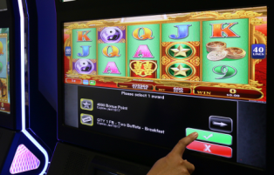
SYNKROS Offers Management™
Further expanding the power of the SYNKROS marketing suite, SYNKROS Offers Management gives players the choice to select from multiple available bonus awards—such as comp vouchers, free play, drawing tickets, tournament entries, and extra point prizes—and receive personalized notification across a variety of touchpoints including kiosk machines, SMS, email, direct mail, and EGM displays. In addition, this enhancement gives operators the flexibility and control to maximize marketing promotions, with seamless, real-time tracking across their player base.

SYNKROS Dashboards™
Konami is expanding the convenience, accuracy, speed, and usability of business analytics with a fast, interactive new dashboard interface created seamlessly within the SYNKROS systems environment. SYNKROS Dashboards gives operators a single location to observe, test, and process dozens of dashboard indicators spanning all major areas of their business, including slots, table games, player loyalty, and marketing. Each customizable dashboard is fully interactive, with unique insights across varied levels of detail. SYNKROS Dashboards further exemplifies the quality and reliability that SYNKROS is known for, and provides the crucial link between a casino’s core gaming system and performance visualization tool.

###

